LARGE SCALE META-ANALYTIC CARTOGROPHY OF HUMAN FRONTAL CORTEX

by

ALEJANDRO DE LA VEGA

B.A., Pomona College, 2009

M.A., University of Colorado, 2012

A thesis submitted to the

Faculty of the Graduate School of the

University of Colorado in partial fulfillment

of the requirement for the degree of

Doctor of Philosophy

Department of Psychology and Neuroscience

2016

This thesis entitled:

Large-scale meta-analytic cartography of human frontal cortex

written by Alejandro de la Vega

has been approved for the Department of Psychology and Neuroscience

Marie Banich

Tor Wager

McKell Carter

Scott Vrieze

Rafael Frongillo

Date

The final copy of this thesis has been examined by the signatories, and we

find that both the content and the form meet acceptable presentation standards

of scholarly work in the above mentioned discipline.

ABSTRACT

De La Vega, Alejandro Isaac (Ph.D., Psychology and Neuroscience)

Large-scale meta-analytic cartography of human frontal cortex

Thesis directed by Professor Marie T. Banich

The field of human brain mapping has made immense progress in recent years by making tens of thousand associations between the brain and psychological states using functional magnetic resonance imaging (fMRI). However, there is a growing appreciation of the limited ability to determine the specificity between brain-cognition mappings in individual studies. Without surveying a diverse range of psychological states, it is difficult to know if a brain region is preferentially recruited by a given state, or a more domain-general process that underlies it. In a related issue, several recent efforts have attempted to find the fundamental computational units of the brain by using statistical learning techniques to form discrete regions on the basis of properties that constrain information processing, such as connectivity. However, it’s not clear how well these brain atlases describe the high-level functional organization of the brain.

In this dissertation, I apply relatively unbiased data-driven methods to a database of nearly 12,000 fMRI studies to comprehensively map psychological states to discrete regions in human frontal cortex– a complex, high-level association area of the brain. On the basis of activation patterns across studies, I identify functionally distinct whole-brain networks composed of spatially contiguous subregions. While each network exhibits distinct functional associations, subregions within each network, show much more similar, yet dissociable profiles. In contrast with strong localizationist accounts, we find distributed associations between psychological states and brain anatomy, suggesting moderate functional selectivity in many parts of frontal cortex.

In the last section, I quantitatively assess various approaches for clustering the brain into discrete regions by comparing novel meta-analytic atlases to existing brain atlases from other brain modalities. Across a variety of metrics, I find evidence that meta-analytic atlases are robust and may provide a better account of the task-dependent organization of the brain than atlases from other brain modalities. I conclude by discussing future approaches for using large-scale meta-analysis to better understand how the brain gives rise to psychological function.

To my parents, Francisco and Adriana

ACKNOWEDGMENTS

CONTENTS

CHAPTER

I. Introduction 1

II. Large-scale meta-analysis of human medial frontal cortex reveals tripartite functional organization 9

III. Large-scale meta-analysis of human lateral frontal cortex 37

IV. Cross-modal evaluation of whole-brain atlases 84

BIBLIOGRAPHY……………………..…………………………………………112

APPENDIX

I. Full associations between LFC regions and topics 129

CHAPTER I

**Introduction**

A fundamental goal of cognitive neuroscience is to precisely map the computational processes performed by anatomically discrete regions in the human brain. Although a precise ‘cartography’ is not sufficient for understanding brain function, it is a [RMF: prerequisite seemed strong to me (how do we know that we cannot understand brain function without a map) but maybe the reference cited really does justify this claim] prerequisite which allows researchers to formulate mechanistic theories of information processing across the brain (Friston, 2002). Functional cartography, or human brain mapping, began by making associations between behavioral changes in response to focal brain lesions and has enjoyed great success in revealing specific patterns of functional specialization throughout the brain.   
Further progress was also made by systematically mapping the electrical response of neurons in animals using invasive electrophysiological methods. For example, in a hallmark study, Hubel and Wiesel mapped the structural and functional architecture of cat primary visual cortex, discovering orientation selective neurons in V1 (Hubel & Wiesel, 1962).

The advent of functional magnetic resonance imaging (fMRI) (Kwong et al., 1992) enabled an explosion of human brain mapping by allowing researchers to measure the whole brain’s response to a relatively unconstrained range of psychological phenomena. In the decades since, tens of thousands of studies have correlated individual activation foci to carefully controlled psychological states to understand the localization of specific psychological states. Moreover, structural and functional connectivity imaging methods have precisely characterized the anatomical and functional connectivity between brain regions, revealing complex whole-brain networks underlying human behavior.

**The importance of large-scale approaches in cognitive neuroscience**

Despite the enormous amount of fMRI studies that have been conducted, there are several roadblocks that prevent a comprehensive understanding of functional-anatomical mappings. A significant limitation inherent to fMRI is a relatively low signal [RMF: noise] to ratio (SNR). As a consequence, the majority of published fMRI studies are vastly underpowered and report a large number of false-positives and inflated effect sizes (Button et al., 2013; Wager, Lindquist, & Kaplan, 2007; Yarkoni, 2009). In fact, the average fMRI study has only around 20% power to detect a medium sized effect (Yarkoni, 2009). Moreover, traditional fMRI analysis techniques conduct what are called ‘mass univariate’ analyses at the smallest unit in imaging: the voxel. After correcting for multiple comparisons, the spatial maps resulting from these techniques comprise a small subset of the true underlying brain signal correlated with the psychological state of interest.

A critical analysis technique that helps overcome some of these shortcoming is quantitative meta-analysis (Wager et al., 2007). In meta-analysis, individual peak coordinates are extracted from multiple studies that purportedly engaged participants in similar psychological states. These peaks quantitatively combined to determine the regions significantly associated with the psychological phenomena of interest. For example, Shackman et al., 2011 used a meta-analysis to map the anatomical overlap between pain, negative affect [RMF: I think you want an Oxford comma here (and throughout)] and cognitive control. Shackman found evidence that these three processes engaged an overlapping section of anterior midcingulate cortex (aMCC) and in conjunction with anatomical and electrophysiological evidence argued that pain and negative affect signal the need to adaptively change motor plans to avoid future negative outcomes.

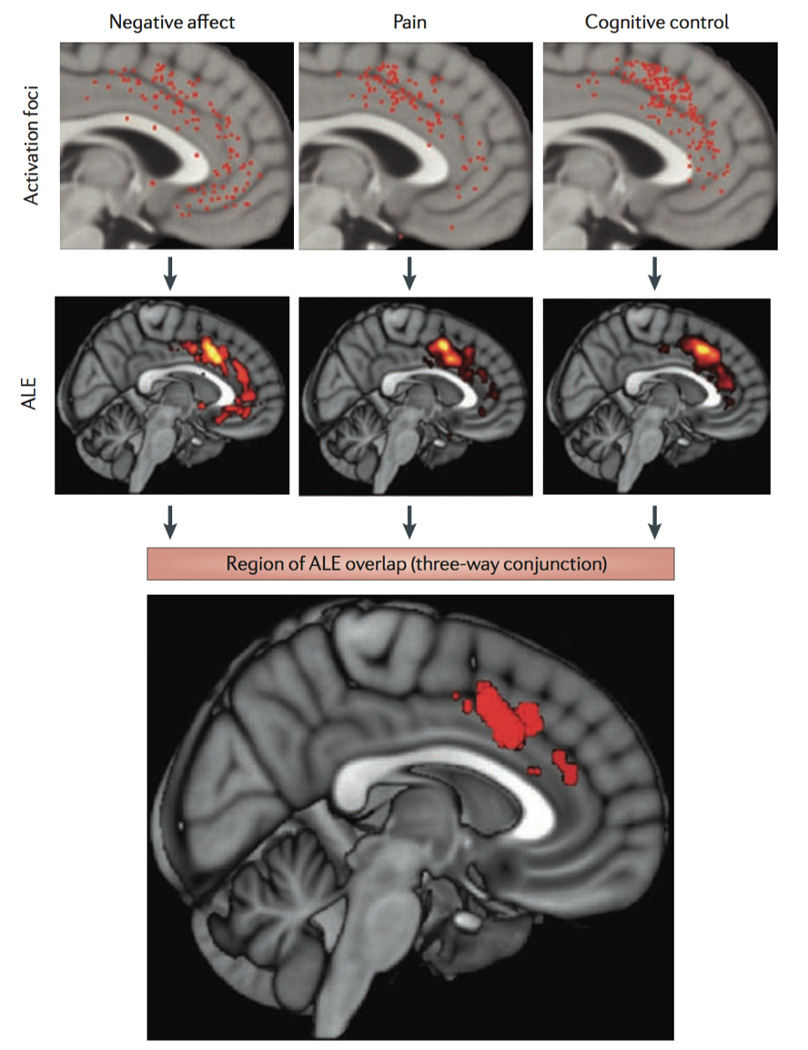

Although meta-analyses allow for fine-grained testing of functional-anatomical hypotheses, without surveying a wide range of unrelated psychological states, it is possible to fall prey to what has been dubbed the ‘reverse inference’ problem (Poldrack, 2006). Traditional fMRI studies are designed to infer the probability of brain activity given the psychological states induced in the study– or what is known as ‘forward inference’ [P(activity|state)]. In contrast, true ‘reverse inference’ requires determining which psychological states are probable given a pattern of brain activity [P(state|activity)]. However, to conduct a proper reverse inference, it is necessary to survey a wide range of unrelated psychological states to determine the specificity between activity in a given brain region and a psychological state. This is particularly problematic as the base rate of activation varies widely across the brain (Figure 1.2). Certain regions, like anterior midcingulate cortex are active in such a large proportion of studies that it is very difficult to determine if specific psychological states (such as pain, negative affect and cognitive control) preferentially recruit this region.

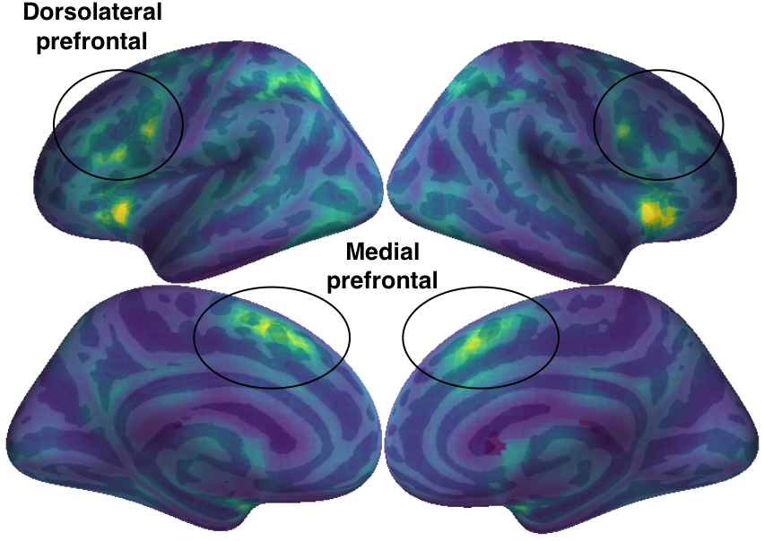

**Figure 1.2**. **Frequency of activation across the brain.** For each voxel across the brain, I display the proportion of studies in which it’s active. Regions critical for goal-directed cognition, such as medial and dorsolateral prefrontal cortex, exhibit high rates of activation, in turn making it difficult to determine which states preferentially recruit them.

Fortunately, there has been a recent growth in [RMF: typo] thedevelopment of large-scale meta-analysis frameworks, such as Neurosynth (Yarkoni, Poldrack, Nichols, Van Essen, & Wager, 2011) and BrainMap (Laird, Lancaster, & Fox, 2005), which allow researchers to more formally formulte of ‘reverse inferences’. This is particularly true of the Neurosynth framework, as it was specifically designed to scale as the literature grows by automatically extracting activation coordinates and semantic meta-data of fMRI studies. As of 2016, Neurosynth includes over 11,000 fMRI studies, encompassing a diverse range psychological manipulations. By widely surveying across the psychological literate, large-scale meta-analysis allows researchers to quantitatively determine the specificity of brain-behavior relationships.

To demonstrate the importance of appropriately modeling reverse inference, we recreated Shackman’s (2011) meta-analysis using forward inference– akin to a traditional meta-analysis– using Neurosynth. Similar to Shackman (2011), we find overlap between pain, negative affect and cognitive control in aMCC (Figure 1.3a; overlap shown in white). However, we also find a very similar pattern of overlap when we perform a forward inference analysis of three theoretically unrelated psychological states: ‘social cognition’, ‘vision’ and ‘long term memory’ (Figure 1.3b). This demonstration highlights the importance of large-scale meta-analyses that appropriately quantify preferential psychological recruitment across the brain.



**Figure 1.3.** a) Forward inference meta-analysis of pain, negative affect and cognitive control, showing distinct overlap in anterior midcingulate cortex (aMCC). b) Forward inference meta-analysis three theoretically unrelated constructs (social cognition, vision and long term memory) shows similarly striking overlap in aMCC. Overlap is indicated in white.

**Finding the right brain units**

A related problem facing cognitive neuroscience is determining how the brain’s complex anatomy is spatially organized into units that give rise to psychological function. It is of great interest to define functionally dissociable units as this can facilitate the formulation of theories linking brain to behavior (Poldrack & Yarkoni, 2016). Much progress has been made on this front by using data-mining techniques on a variety of brain data from various modalities. For example, a particularly popular strategy has been to apply unsupervised learning algorithms to connectivity data that describes either the anatomical connections (Beckmann, Johansen-Berg, & Rushworth, 2009; Johansen-Berg et al., 2004) or temporal correlations in fMRI signal (i.e. functional connectivity; Craddock, James, Holtzheimer, Hu, & Mayberg, 2012; Shen, Tokoglu, Papademetris, & Constable, 2013; Yeo et al., 2011). These methods have greatly informed our understanding of the organization of the brain, revealing large-scale brain networks that were not previously widely appreciated (Figure 1.4).

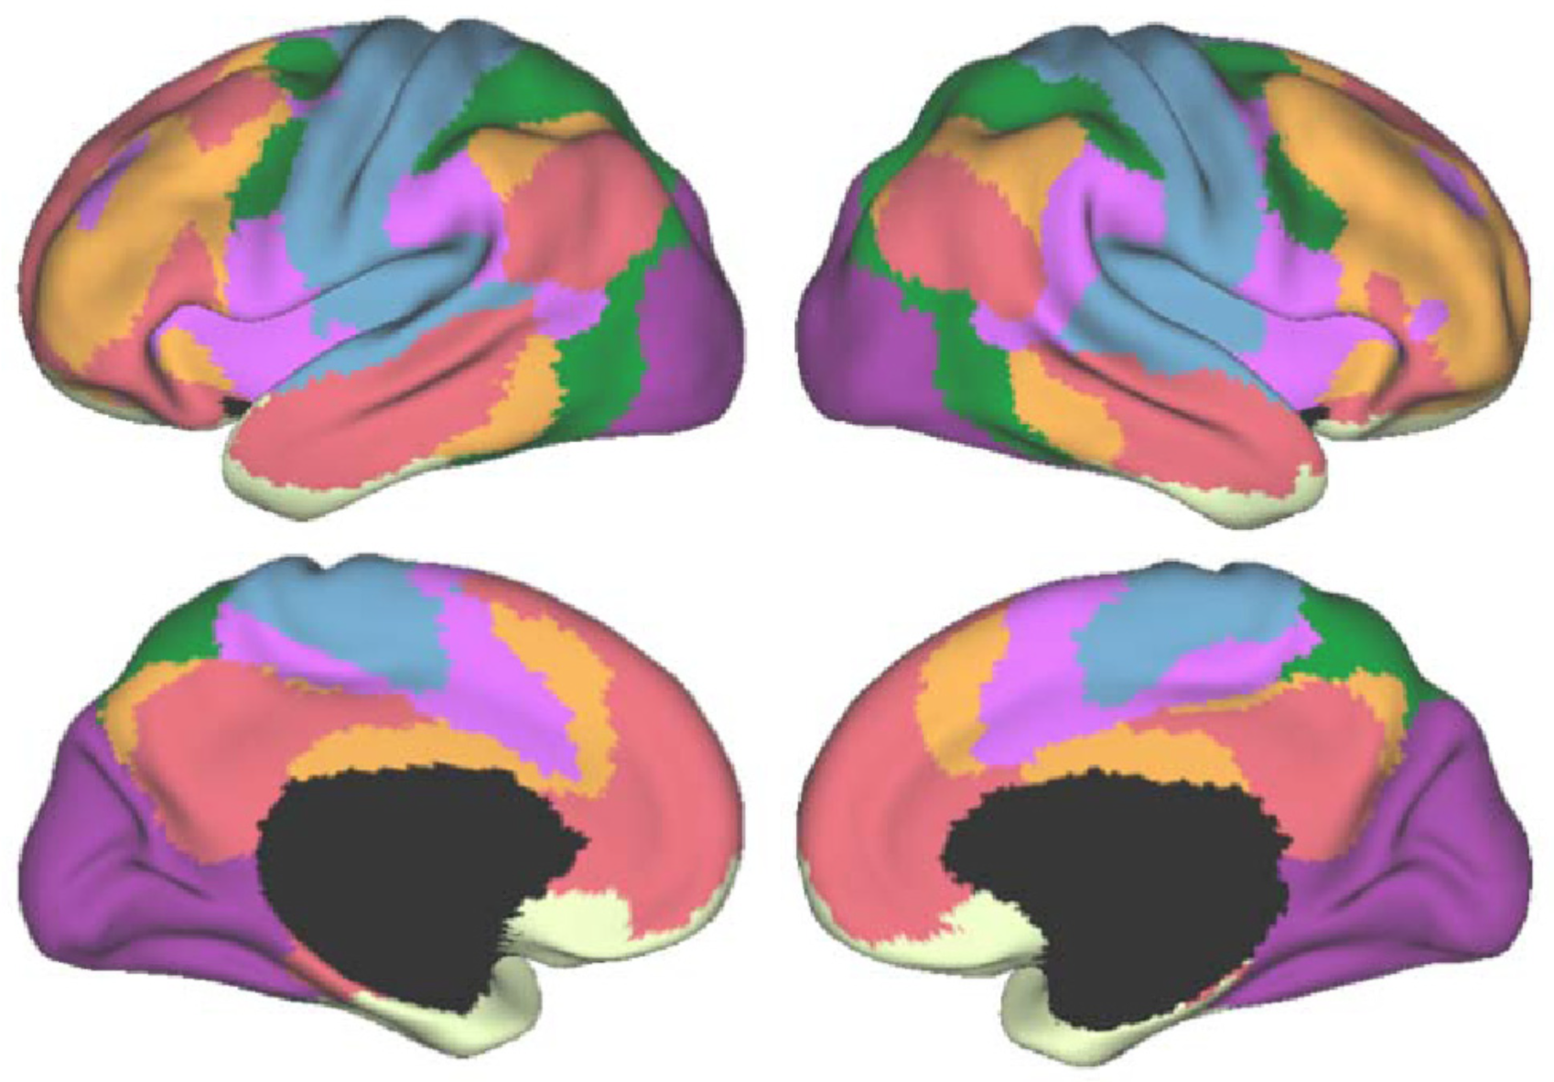

**Figure 1.4.** Seven-whole brain networks estimated from intrinsic functional connectivity in resting state fMRI. Reproduced from Yeo et al., (2011).

However, a shortcoming of these brain-centric methods is that they are generally void of functional data linking brain units to distinct psychological states. As such, these methods cannot directly speak to the psychological function of these brain regions. Moreover, it is not clear if the units derived from these various brain measures are necessarily the units that best explain the functional differences observed during behavioral performance in task-related fMRI.

**Dissertation overview**

In the present dissertation, I seek to advance large-scale meta-analytic techniques by making a link between psychological function and anatomical brain units in three investigations. [RMF: I'd make it a bit more clear where the split is between Chpt 2 and 3] In the first two investigations, I use unsupervised data-driven techniques to identify spatially distinct regions in lateral and medial frontal cortex on the basis of co-activation patterns across a wide variety of fMRI studies. I then use classification techniques to decode the psychological states that best predict activity for each region, revealing theoretically informative brain-behavior mappings. I chose to study frontal cortex as the topology of psychological states is less well understood in higher-level association cortex. Moreover, as a consequence of frontal cortex being centrally involved in a wide variety of behaviors, the base rate of activation in certain frontal regions is very high and particularly vulnerable to the ‘reverse inference’ problem. These two studies provide comprehensive and relatively unbiased functional-anatomical mappings of human frontal cortex.

In the final chapter, I evaluate the quality of various strategies for meta-analytic parcellation and compare the utility of these meta-analytic brain atlases to those derived from other brain modalities. In an effort to objectively choose ‘the right brain units’, I use classification to evaluate how well brain atlases from different modalities are able to predict psychological states. In this study, I find evidence that meta-analytically derived atlases may provide a more accurate and useful representation of the underlying functional-anatomical organization of the human brain than those derived from various other modalities. I conclude this dissertation with brief concluding remarks summarizing the contributions of the present studies.